**Guest Information Letter**

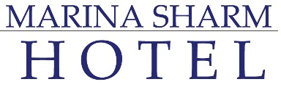

**Marina Restaurant**

|  |  |
| --- | --- |
| Breakfast Buffet | : 07.00 AM – 10.00 AM |
| Lunch Buffet | : 13.00 PM – 15.00 PM |
| Dinner Buffet | : 18.30 PM – 21.30 PM |

**Hotel Bars:**

|  |  |
| --- | --- |
| Marina Bar | : during meals |
| Lounge Bar | : 24/7 Extra Charge |
| Garden Bar | : 17.30 PM – 22.00 PM |
| Palm Bar | : 10.00 AM – Sunset |

**Snacks:**

|  |  |  |
| --- | --- | --- |
| Palm Bar | : 11.00 AM – 12.00 PM | Late breakfast |
| Bay Watch Restaurant | : 16.00 PM – 17.00 PM | Sandwiches/Snacks |

**The Grill Restaurant: (Pool-Sea View)**

A la cart restaurant serving Oriental food. Pre-reservation – free once/stay instead of dinner.

**Kalimera Beach & Restaurant: (Sea View)**

Pre-reservation – located at the beach area.

* **Greek Restaurant: ( Sea View):**

Pre- reservation set menu restaurant with International and Greek menus, free once/stay.

**Room Mini-bar:**

* Arrival day is free of charge, rest of the stay items will be against charge.

**Beverages:**

Soft All Inclusive Concept:

* Available: Mineral Water, Soft Drinks, Hot Drinks and Juices.

Hard All Inclusive Concept:

* Available: Mineral Water, Soft Drinks, Hot Drinks and Juices, Local Alcohols & Local Beers.

Half Board Concept:

* Breakfast: available-Mineral Water, Hot Drinks & Juices.
* Dinner: available-Mineral Water & Juices.

Bed & Breakfast Concept:

* Available: Mineral Water, Hot Drinks & Juices.

**All drinks are served in one-way cups (environmental friend)**

**Extra charge drinks: Turkish coffee, Fresh Juices, Ice cream, Imported Alcoholic Drinks & Wine.**

**Extra Charge Services:**

* Room Service (24/7) – dial no 3.
* Doctor Clinic (24/7) – dial no 1 (reception).
* Laundry Service – dial no 4 (laundry pick up).
* Shuttle Bus Service – dial no 1 (reception).
* Spa Service – dial no 6635.

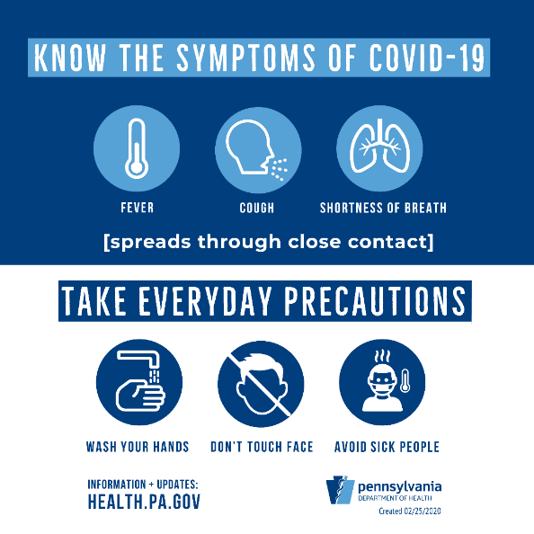

All Inclusive Concept

Half Board

Concept

Bed breakfast

concept

**

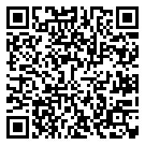

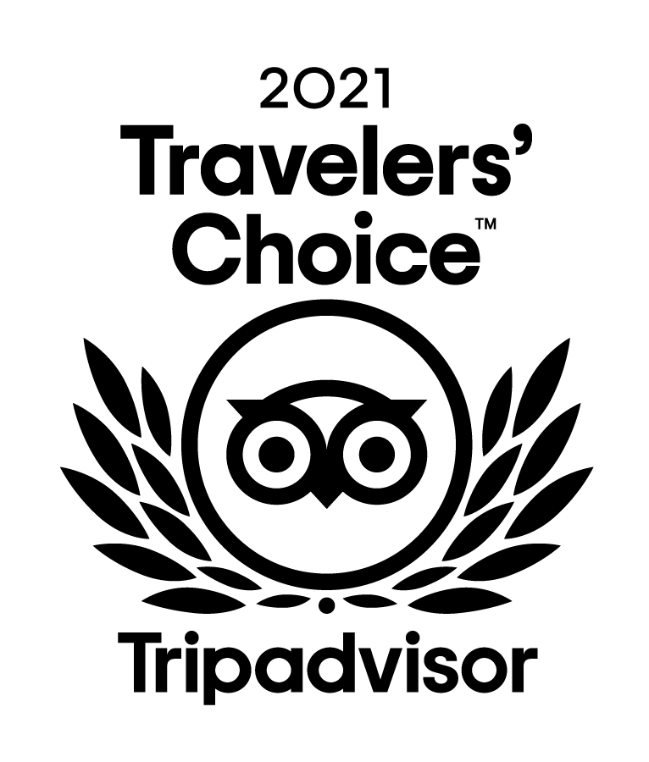

**Welcome in one of Egypt's most environmentally friendly hotels - a “Green Star Hotel”**

**As “Green Star Hotel” we are committed to the reduction of our carbon footprint and the protection of our environment. We strive to preserve the flora and fauna of our landscape and the unique marine life and biodiversity of Egypt. By implementing numerous environmental activities in the areas of conserving energy and water, reducing waste generation and recycling, we are committed to environmental protection in every section of our hotel.**

**GREEN STAR HOTEL **

**Hotel Regulations**

* **Guest check-in** –after 14.00PM.
* **Guest check-out** – 12.00PM, otherwise guest need to contact the reception for any further request or extensions that will be against charge.
* **Swimming wears** are not allowed in the indoor/closed outlets.
* Guest is not allowed to take the food or drinks outside the restaurants outlets according to **“Hotels Health, Safety and Hygiene Regulations”.**
* **Room’s linens, pillows, blankets**, etc. are not allowed to be taken out of the room for more hygiene and safety procedures.
* **Room Safety Box** is available for guest valuable possessions, and the hotel have no responsibility for the loss of any of valuable holdings kept outside the safe.
* Kids aren’t allowed to present around pool/beach areas without their parents.
* **Pets are not allowed into the hotel.**

**Guest Information Letter**

