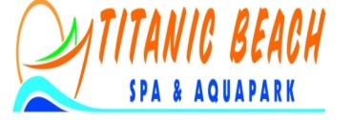

- Category:5 Stars Deluxe Royal All Inclusive

- Location :Located right at the shore of the Red Sea approx. 10 Km from the Air port

- Transfer: Airport pick up upon request, Daily scheduled trips to the City center

- Rooms:
- 474 Standard Rooms (40 sqm)
- 06 Rooms for the Disabled (40 sqm)
- 83 Family Rooms (50 sqm)
- 40 Junior Suites (50 sqm)
- 04 Executive Suites (75 sqm)
- 01 Presidential Suite (120 sqm)

All our Rooms and Suites are equipped with split Air Condition, private Terrace or balcony; satellite LCD-TV, Bathroom with shower, hair dryer, Safe Deposit Box free of charge, Mini Bar with water and soft drink including

- Conference: conference room for 400 Pax, with a break up rooms full equipped.

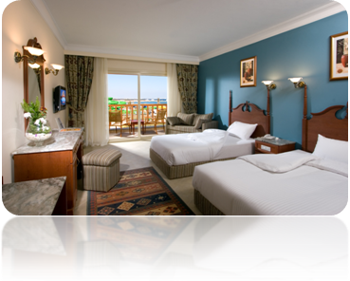

Restaurants and Bars

- Rose" Main Restaurant
- Jack" Main Restaurant
- Cal" Main Restaurant
- Tarboush" Oriental ala card Restaurant
- Little Italy" Italian ala card Restaurant
- China Town" Chinese ala card Restaurant
- Fish" ala card Restaurant
- Pirates" Lobby Bar
- Captain's Inn" Bar
- Oasis" Pool Bar
- Sailors" Beach Bar
- Comfort Club VIP
- Waves" Disco
- Titanic Ball Room

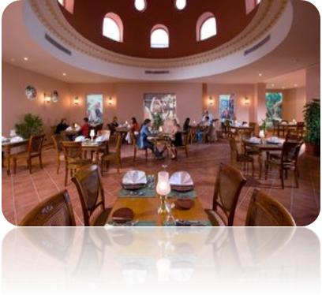

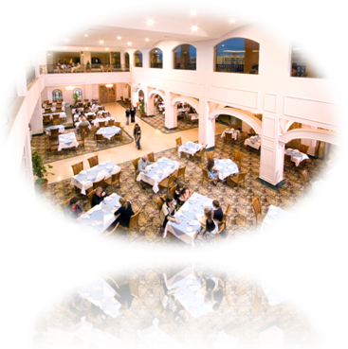

Entertainment:
Our multilingual Animations team is presenting you a daily entertainment program with numerous activities of team sports and competitions, and a daily evening program with vibrant shows and Disco.
Our young guests will enjoy their Kids Club with Kids Cinema and numerous other interesting activities as well as a special Kids Disco.
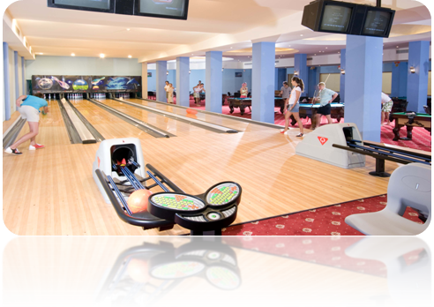
- Volleyball
- Boccia
- Soccer
- Gym
- Water sports
- Diving Center
- Aqua Center
- Games
- Children's playground
- Aqua Park
- Relaxation Beach Area
- Mini Club

Special Features Internet Café, Game room, bank,
Hairdresser, 24 hours Doctor Service,
Limousine service, Shopping Arcade,
Laundry & dry clean service
Sports /Wellness/Leisure Facilities
16.000 sq m pools around the resort with one heated pool
A long sandy beach with a jetty and a marina
Spa & Wellness center (sauna, Turkish bath, GYM, massage, whirl pool)
Bowling, tennis courts, billiard room, volleyball, pool games, table tennis, boccia, mini golf, aerobic
Diving and Aqua center
Aqua Park: All day long with several water slides and games, heated water, wave pool and rafting river, additional 6 kids slide with separate pool and actives pirate ship
Children: Kids Club, Kids buffet, Cinema.
Languages English, German, Polish, French, Russian
Parking Private car Parking
Currency EGP, Euro, GBP, USD
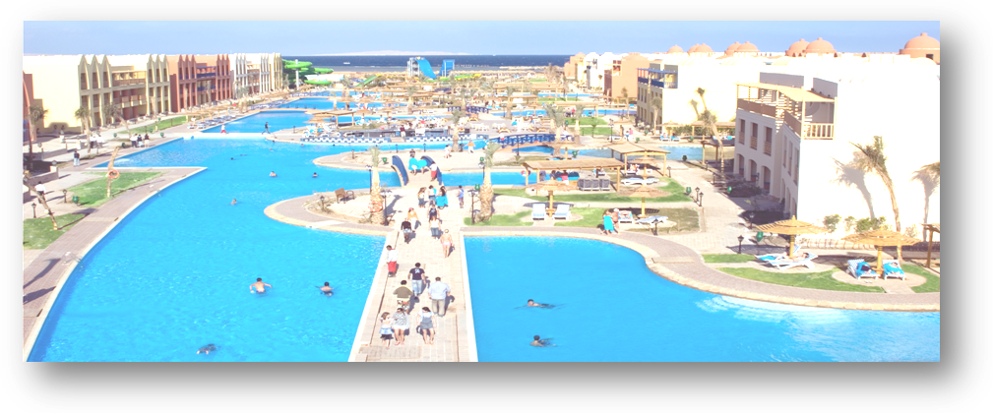
Credit Cards Master Card, Visa Card

Contact E-meil: info@titanicgroup.com
Web Address: www.titanicgroup.com Tel.: +2(065) 346 1420 Fax: +2(065) 346 1430

